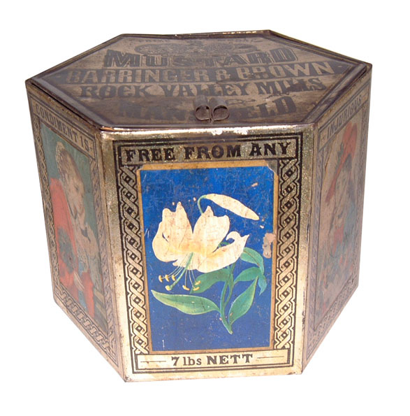 | 1881 – 1890 | 7lb Mustard tin C. 1882. The earliest tins produced by Barringers were made in 1863. Paper labels were used to decorate the product. The tins of mustard were sold to Grocers who then sold on the mustard in 1d and 2d packs.
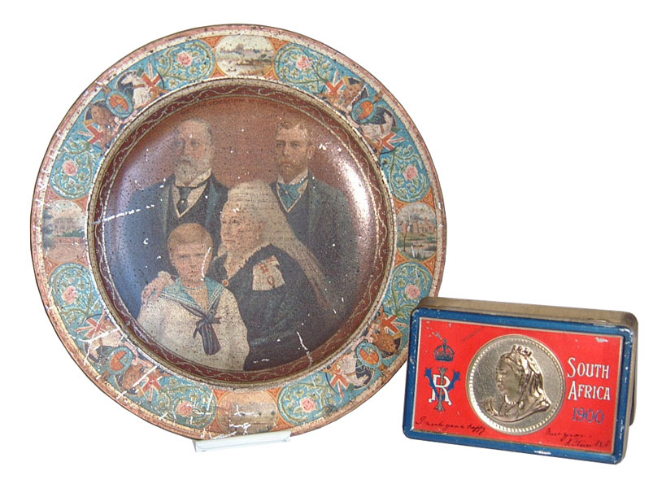 | 1891 – 1900 | The plate was made to commemorate Queen Victoria’s Diamond Jubilee in 1897 and the other tin was made to send Royal Greeting to South Africa for the 20th Century.
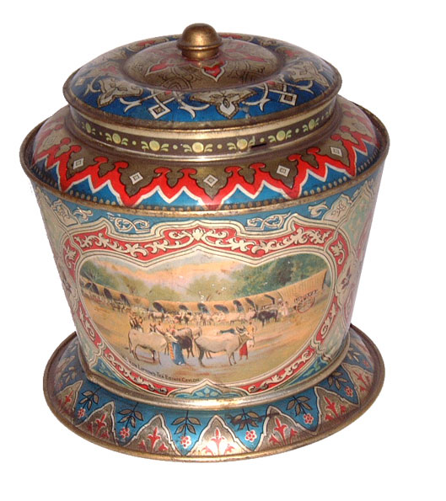 | 1901 – 1910 | Satsuma Tea Caddy made for Lipton’s Tea in 1907
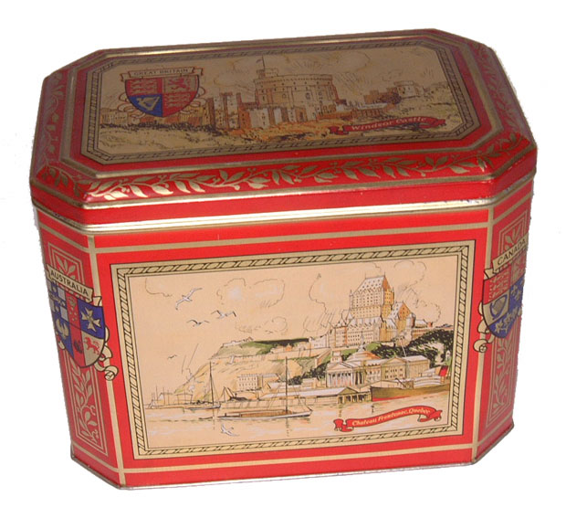 | 1911 – 1920 | Bluebird tin made for McVitie & Price
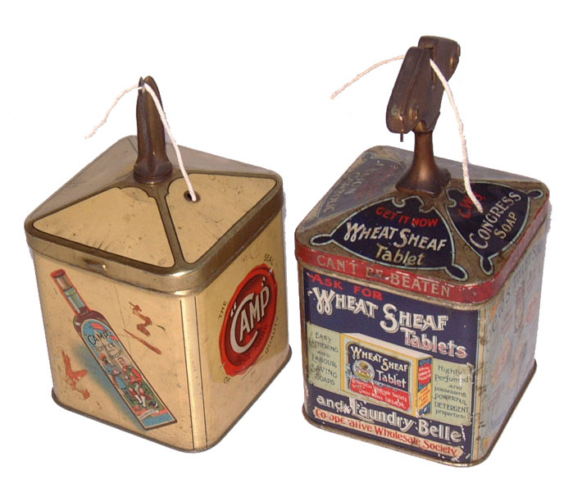 | 1921 - 1930 | Some of the earliest forms of promotional packs were weighted tins for cutting string. These examples were manufactured during the 1920’s
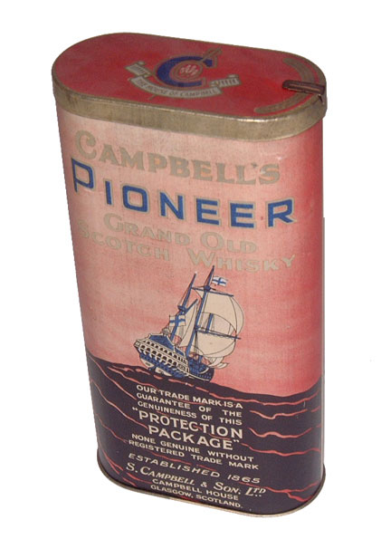 | 1931 – 1940 | Export packaging for the House of Campbell. Note the tamper evident seal cutter in the lid.
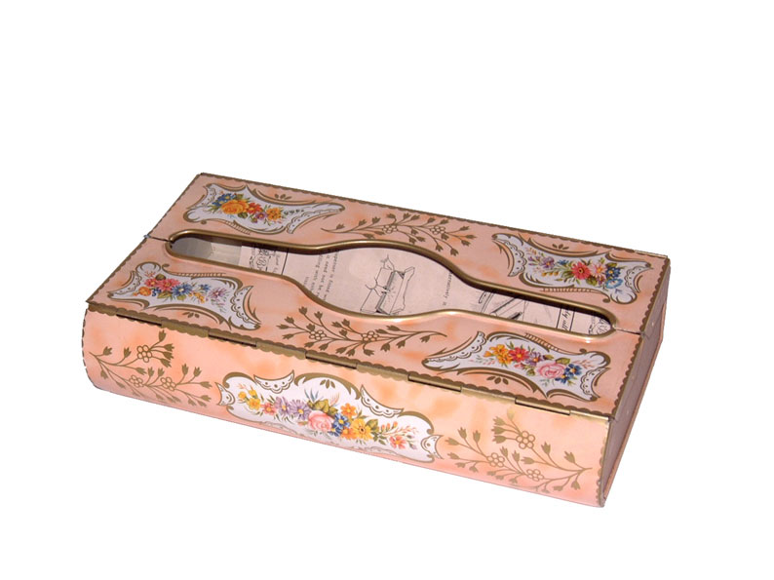 | 1941 – 1950 | Tissue dispenser – part of the extensive houseware products manufactured at Mansfield in the 1940’s and also the 50’s and 60’s.
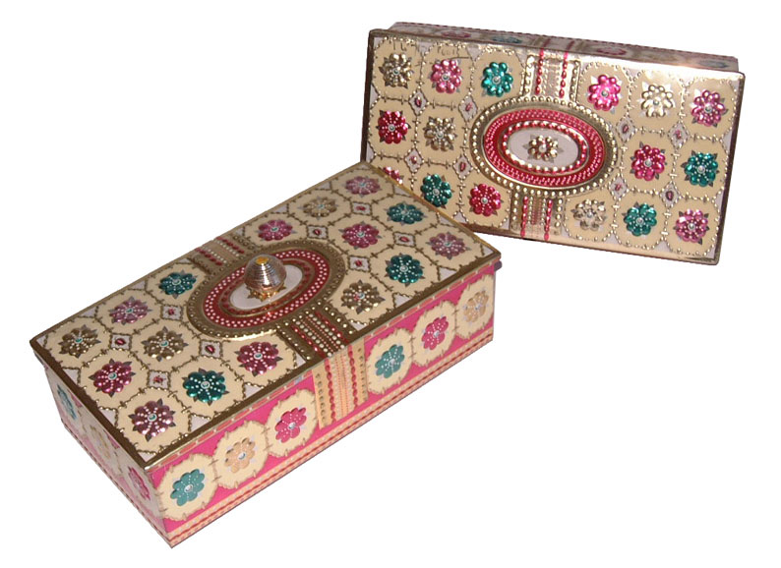 | 1951 – 1960 | These highly reflective and embossed designs were popular for US export in the 1950’s.
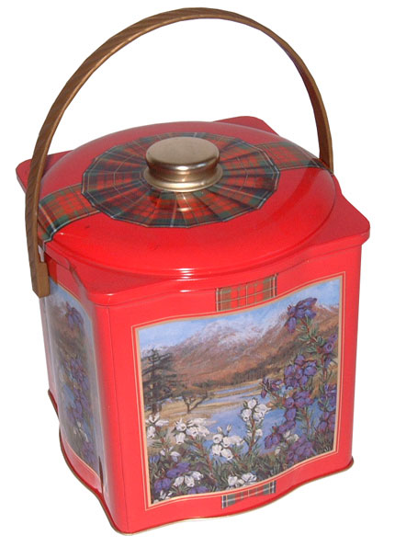 | 1961 – 1970 | Crescent biscuit tine made for Peek Frean
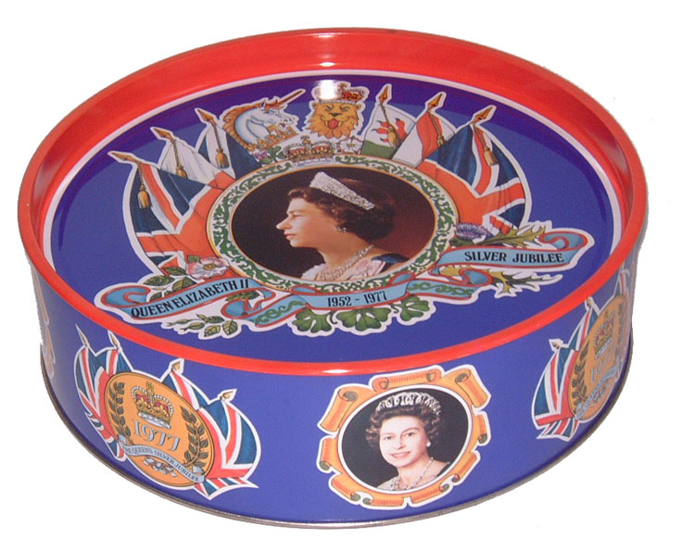  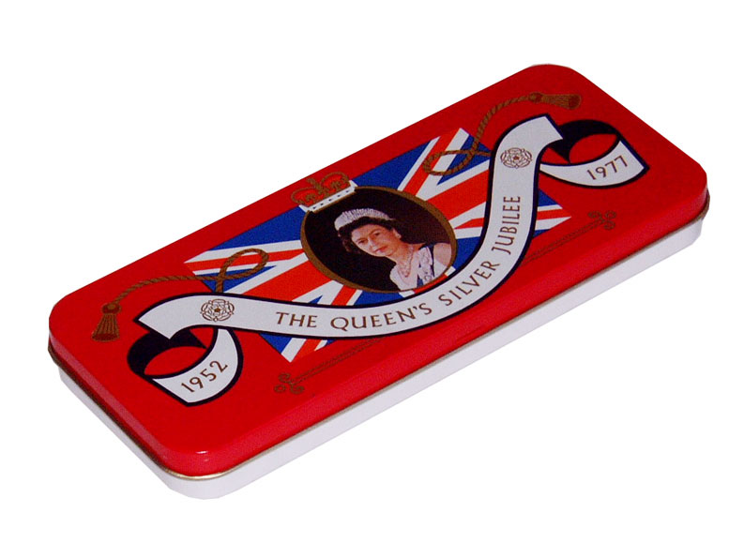 | 1971 – 1980 | Cake tin made to commemorate Queen Elizabeth’s Silver Jubilee in 1977
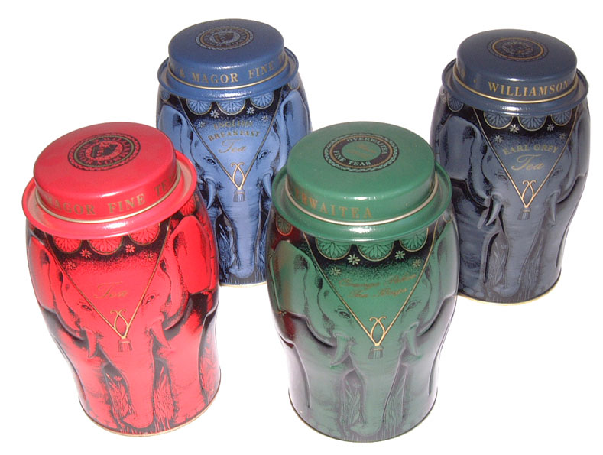  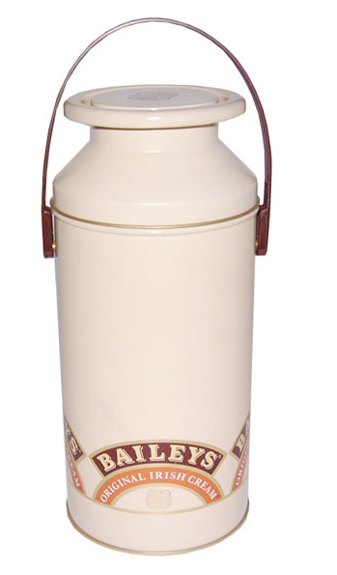 | 1981 – 1990 | Elephant tins produced for Williamson & Magor – unique debossing technique and a Packaging World Star winner in 1992.  The “churn” was the first in a long line of containers we made for Baileys.
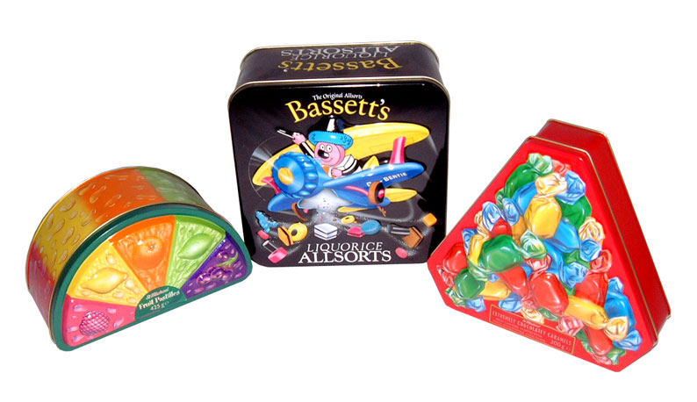  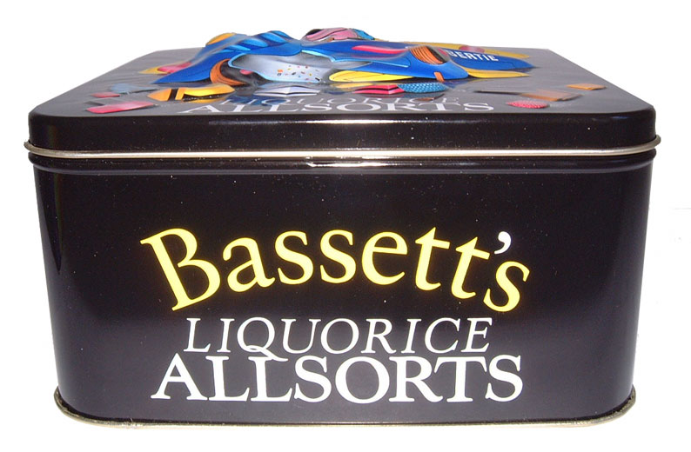  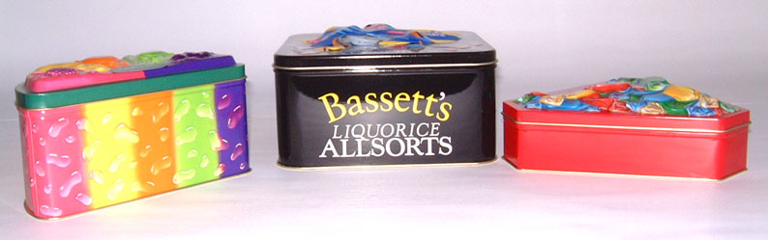 | 1991 – 2000 | Decorative bulged emboss at the time was unique to Crown
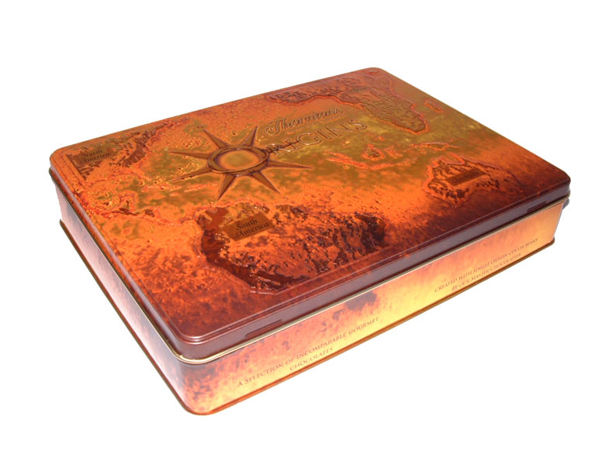 | 2001 – date | Tin made for Thornton’s Origins – award winning design

0314

