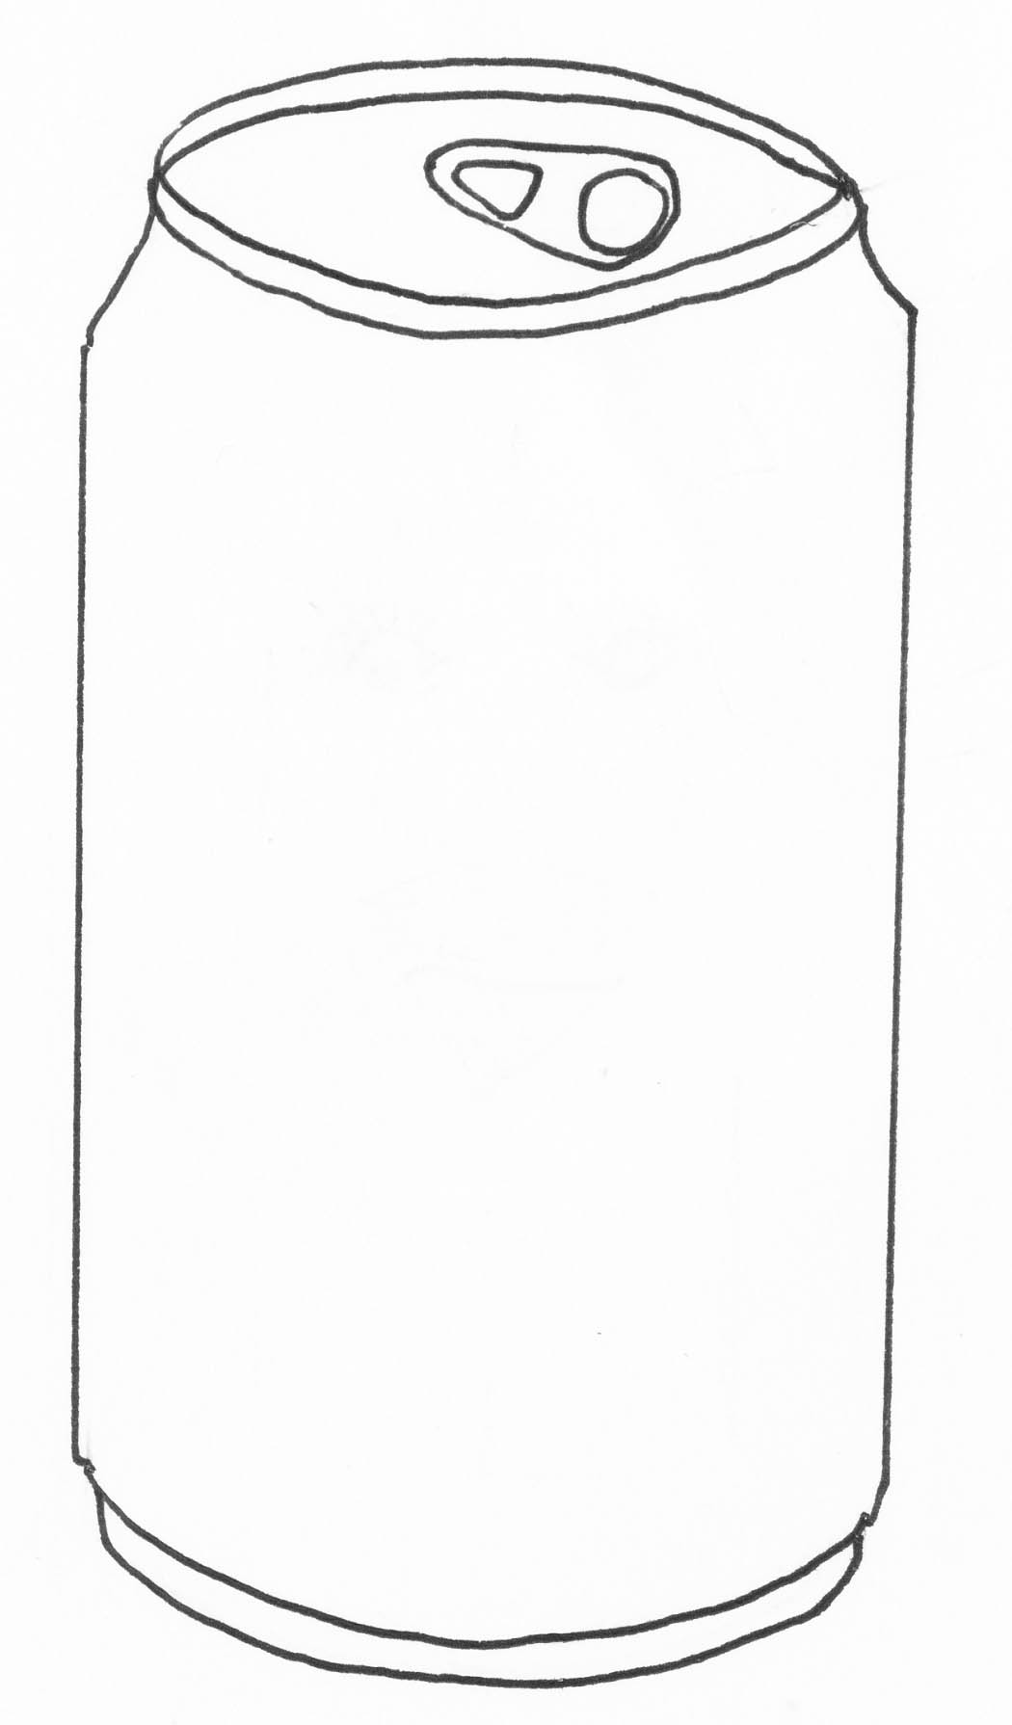
Hi Kids!
My name’s Alice Aluminium and I’m an aluminium drinks can!
I bet you didn’t know all these facts about aluminium!!

Make this drinks can into a cartoon character called Alice Aluminium!
Then use the ‘Did you know?’ sheet to fill in some facts about aluminium in Alice’s speech bubbles

