

Age Group: Yrs 4 - 6
Curriculum Links: Creative use of ICT to support and enhance learning.

What do I need?
- Access to data handling applications such as Excel

The activity, ‘Can Count’ asks children to carry out a series of audits on the canned products in their home, local shop or supermarket. An activity sheet gives some data to use. This lists all the products found in Mrs Brown’s cupboard.

In this activity, children use MS Excel to input data and to create a graph. They then copy and paste the graph produced into another document where they explain their results.

This activity shows the Excel process using Mrs Brown’s cupboard audit. It could be used for the children’s own cupboard audits or those from their local shop or supermarket.

The school may have a different data handling package in school which children could use. This lesson presumes minimal experience with MS Excel.

Using the ‘Mrs Brown’s cupboard audit’ worksheet, ask the children to create a spreadsheet that they can fill in to show which items that fall into each category. Put the category titles in the top row and make them bold and underlined so they show up. Then work through the list of items, typing each into the correct category column. If there are more than one tin of the same item, copy and paste the correct number into the column, i.e, there are 3 tins of dog food. Type ‘dog food' into a cell, copy it, click on the cell below and paste.

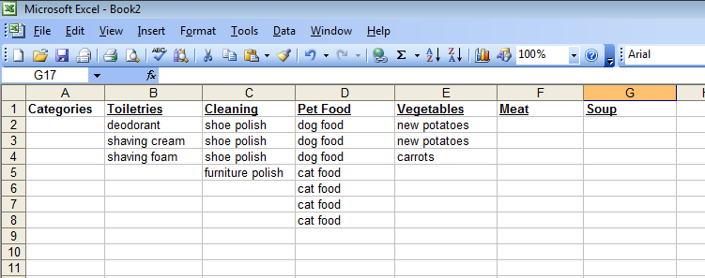

Once all the items have been typed in, in the correct category, the children can total them up to see how many there are in each column.

Once this information is gathered, a new sheet can be prepared. This time, the children fill in a number to indicate how many tins there were in the cupboard under each category.

In this lesson, the children use the information in their spreadsheet to create a graphical representation. Once completed, then all the cells with information in need to be selected. This can be done by dragging over all the cells. Select custom types and choose the graph you want. By clicking ‘next’ you can label the graph and axes.

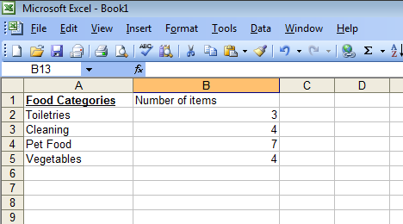

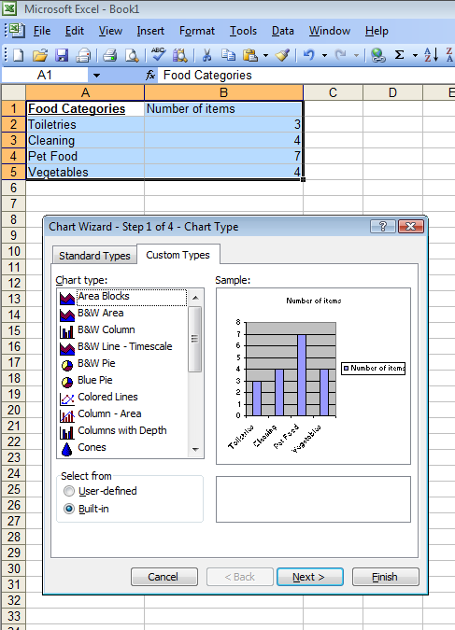
Depending on the ability of the group, different graphs and charts can be created and customised.

Once completed, the graph can then be copied and pasted into a Word processing package and children can complete their report.

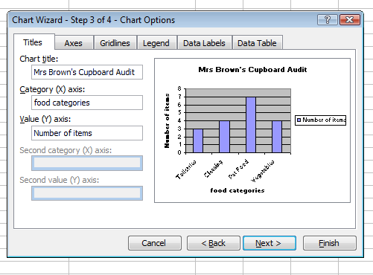

Once the children have worked through the audit for Mrs Brown’s cupboard, they can repeat the process for their own home audit.

Encourage the children to create attractive presentation pages that include titles, areas of text and their graphs. These can then be displayed in the classroom. A word processing package can be used for this element of the activity.

Discuss with the children the advantages of using Excel. Compare this method to other data handling packages that may be available.

For children more familiar with Excel, formulae can be used to check totals. A combined class audit could then be created, with individuals inputting their data.

