

Age Group: Key Stage 2 (Years 4-6)
Curriculum Links: Science: A.T 1 – Planning and carrying out investigations.
What do I need?
- Range of paper types, glue, scissors
- Paperclips

This unit is based on the techniques used in can making to join the main body of the can to the base or the lid. These parts are joined by interlocking folds which are then pressed hard

together. This unit gives Key Stage 2 children the chance to investigate the strength of a range of folds in a scientific way and to collect data.

Top of can

Folds interlinking and being pressed together
Sides of can

Which Investigation? – Work Sheet 1
Paper Basket Templates – Work Sheet 2
Fabulous Folds Investigation – Work Sheet 3

In this unit, children will be able to carry out one of a selection of investigations that look at how folds can be used to join two pieces of paper together. The children will need to have had experience in carrying out investigations and this task gives them the opportunity to bring their understanding together in the form of an investigation they will not have done before.

Before starting this unit, the children need to understand the context of this within metal packaging. There are numerous times when materials need to be joined together. This may be the two sides of the rectangle of steel, to make the cylinder of the can. It may be the top sealed onto a two-piece can or the top and bottom on a three-piece can. The join needs to be easily made by the machines available and be strong and reliable. Numerous tests will have gone on when decisions were made as to how this would be done.

When the top is fixed onto a can, the two edges are folded, they are interlinked and then pressed together. This is an easy and effective way of joining.

Explain to the children that they are going to have the opportunity to investigate one of four investigation questions linked to this idea. They are going to have to plan the investigation, carry it out and collect data.

The four investigation questions are:

- Does the number of folds made affect the strength of the join?
- Does the length of the fold affect the strength of the join?
- Does the width of the paper affect the strength of the join?
- Does the type of paper affect the strength of the join?

These are summarised, with diagrams, on Work Sheet 1.

The investigation is going to be done using two strips of paper that can only be joined using folds. Attached to the bottom strip will be a small paper basket in which paper clips, or other small weights can be placed. The weights will be added to the paper basket until the folded join pulls apart. A template for making the paper basket is available on Work Sheet 2.

Discuss with the children the principles behind this investigation. Allow them time to look at Worksheet 1 which shows the different questions that could be investigated and discuss these with them.

The children will need to think about how to make their investigation a fair test. If they start by thinking about the variables that can be changed, then they can ensure that if they change one of these, then all the others must remain the same:

Variables:

- Width of the paper strips
- Type of paper used to make the strips
- Number of folds used to hold strips together (italics indicate the four
- Length of the fold used to hold the strips together investigation options)
- Length of the paper strips
- Weights used (paperclips)

Ensure that the children understand that they are only changing ONE aspect and then they must ensure that ALL the others remain the same.

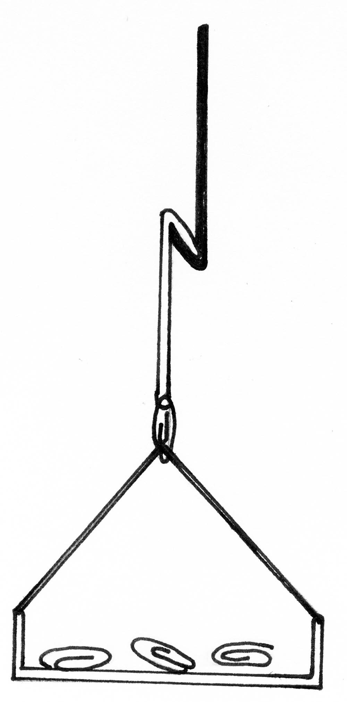

Two strips of paper held together with fold(s)

Paper basket attached to bottom of piece of paper with a paperclip.

Paper basket with paperclip weights

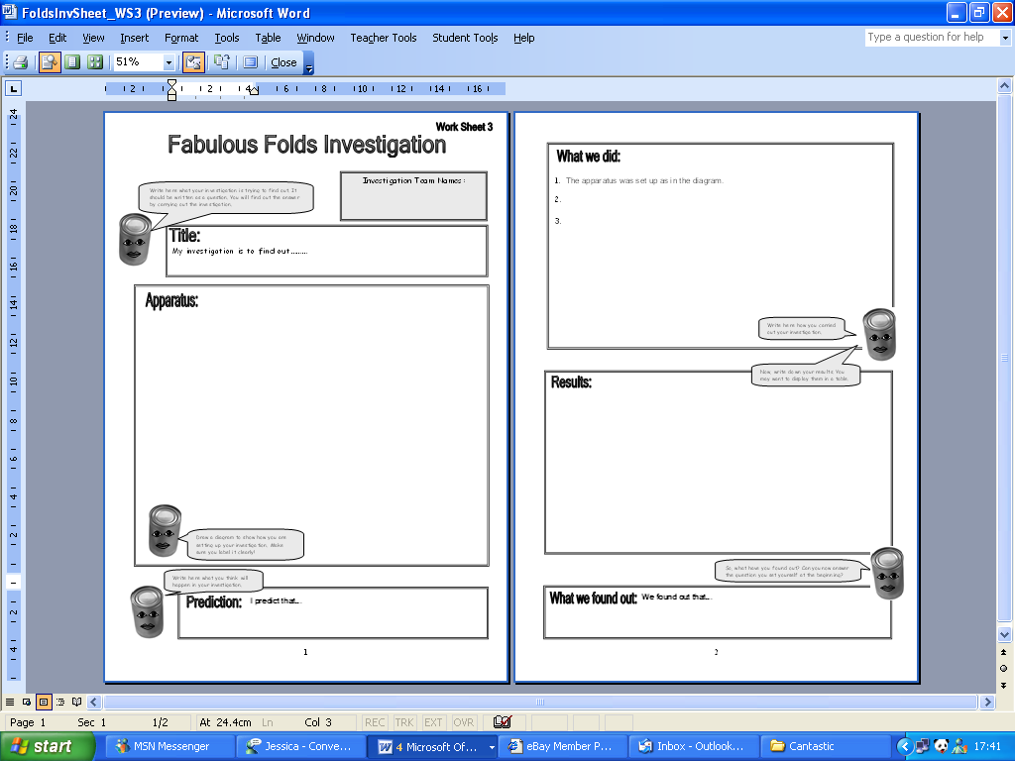

There are many ways that this investigation can be varied. Less able children can work through one of the investigations with an adult. More able children can be given more responsibility to plan and carry out the investigation on their own.

Much work can be done with the data collected. Means will need to be calculated and then results can be displayed in a tabular or a graphical way. Some children may be able to use ICT to write-up their investigation and present results.

Once they have discussed this, understood the principles behind the investigation and know what investigation they are going to tackle, then they will need to make their paper basket. Photocopiable templates are available on Work Sheet 2. The triangles at the side fold up to provide a way of attaching the basket to the base of one of the paper strips. The best way to join it is by piecing a hole through both (or use a hole punch) and ‘threading’ the paperclip through. Treasury tags are another option.

The children will then need to cut their paper strips (all the same size unless they are doing the investigation that is looking at whether the width affects the strength of the fold.) They may also need to do a couple of practice runs as they will need to ensure that their fold is always the same, unless they are varying that as part of the investigation. Recycled paper from the classroom could be used.

Remind them also that they should predict which will be the strongest and should repeat the investigation three times for each change to check their results.

Allow them sufficient time to carry out the investigation.

A write-up template is available as Work Sheet 3 and this can be used to explain predications, how they carried out the investigation, what results they obtained and why they thought this was the case.

Pull the children together at the end of the investigation to enable them to share their results with the rest of the class.

