

Age Group: Years 2 - 6
Curriculum Links: Art & Design: designing the game, Literacy: Persuasive writing, newspaper report, instructional texts. ICT: Adverts, PowerPoint

What do I need?
- A selection of more unusual tins if possible
- Some examples of simple games

Metal packaging is a growing industry, not just in the production of food containers, but also in the more creative markets. We are all familiar with the vast array of beautiful tins we can purchase at Christmas with the ‘present’ value of alcohol and biscuits rising if they are presented in a decorated tin. A tin like this lasts many years and most of us have one somewhere in our households. With printing and moulding techniques moving onwards, more elaborate shaped and decorated tins are becoming available and items that wouldn’t usually be presented in a tin are now being seen on our shelves. Products ranging from umbrellas, underwear, watches and phones can now be bought in an attractive tin!

It is on this theme that this unit is based. The children become designers for MPMA, coming up with a new, exciting use of a can / tin that contains a game, the twist being that the container must become an integral part of the game.

Design Brief – Work Sheet 1
Designer’s Ideas – Worksheet 2
Can Templates – Worksheets 3, 4,and 5

Start the lesson by getting the children to brainstorm all the things they think they could buy that come in a tin or a can. (If you have already done a similar thing with one of the other units from the MPMA website, then you may wish to narrow this down to not include the standard ‘baked beans’ style cans.) Working in groups, with large pieces of paper, allow the children to discuss this and write down all their ideas. Younger children could brainstorm as a class or with an adult scribe.

Once the children have had enough time to think about this, have a look at their ideas. Can they now group / sort their products in any way? They may be able to group tinned fruits, vegetables etc together. Have any children come up with items that are not food? Discuss their findings and then, if possible show them some tins that maybe not the most commonly seen examples, i.e. Christmas promotional alcohol or biscuit tins, paint tins, varnish or what about shoe polish?!

Now ask the children to think again about where they might have seen other products sold in a tin. They may have received a watch or a mobile phone in a tin. They may have some examples at home that can be shared with the class.

Explain to the children that they are to become designers for MPMA (Metal Packaging Manufacturers Association). Tell them that a company has produced three tin shapes and they can choose one. (This information is available on the ‘Design Brief’ Worksheet 1.)

The company want their designers to design a game to be sold in one of these tins, but the tin must become part of the game itself, not just somewhere to store the game! These tins are all made from steel, so they are magnetic. The tins can be printed with any design and the children can use anything you want to make the other parts of your game. It could be a game that already exists, like ‘noughts and crosses’, or ‘Ludo’ or a new game that they have designed! One designer’s ideas are provided for them to have a look at. (See ‘Designer’s Ideas’ Worksheet 2.)

13 cm
7 cm
25 cm
8 cm
23 cm
5 cm
The first is a normal tin, a bit like the one that baked beans comes in, except it has a lid that can be screwed on and off.

The second is a tall ‘biscuit’ type tin, with a screw top lid.
The third is a flat, round tin with a screw top lid.

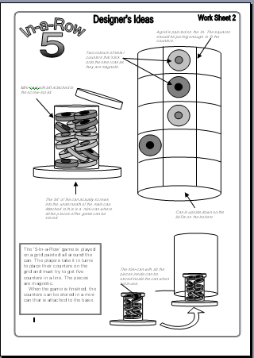

Part 1: Initial Ideas

The children will need time to brainstorm and come up with ideas of their own. You may wish children to work in pairs or small groups, although some may prefer to work alone. Allow children time to get down on paper what tin they wish to use, what they think their game will be and what the components of their game will be. They need to think about:

- What the game is going to be
- What the object of the game is
- How the tin is used as part of the game
- What other parts make up the game
- How the other parts of the game are stored

Part 2: The Design Phase

Once the children have decided the above, then they may be ready to start their design.

There are three worksheets that depict each of the three tin designs available (Work Sheets 3, 4 and 5). Children can use the appropriate one of these to draw their game design. They will need to clearly draw, label and annotate this sheet so all the information to make the game is there. They may need an additional sheet if their game involves lots of additional components.

Part 3: Advertising!

Once the children have completed the design phase of their work, they will need to think about how they might advertise their product. Younger children could make up a simple TV advert. Older children could create adverts with persuasive texts or even create a PowerPoint presentation about their product!

Finally, display the design ideas and the advertising. Which games would the class like to be seen made? What made these designs particularly attractive?

In some cases, it may be possible for the children to make some ‘mock-up’ games. The tins could be made out of card and decorated and the game components be created out of paper or card to show what the game could really look like.

There are lots of ways of extending this work, particularly within Literacy work in Key Stage 2. Children could use their game as the stimulus for a range of different writing activities:

- Persuasive writing to advertise and sell their product
- Newspaper article about the release of their game in the shops
- Instructional text explaining how to play their game

ICT skills can also be utilised in the production of adverts on the computer or with PowerPoint presentations about their games.

