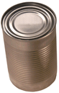
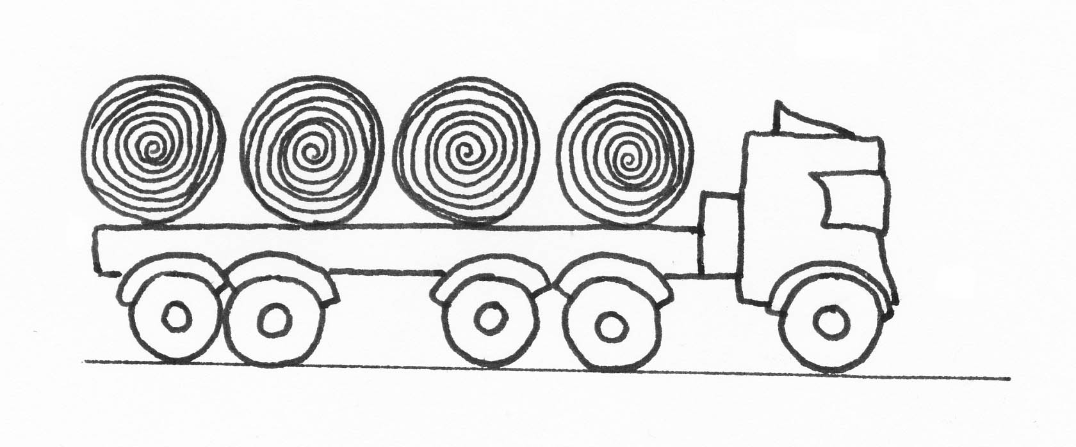
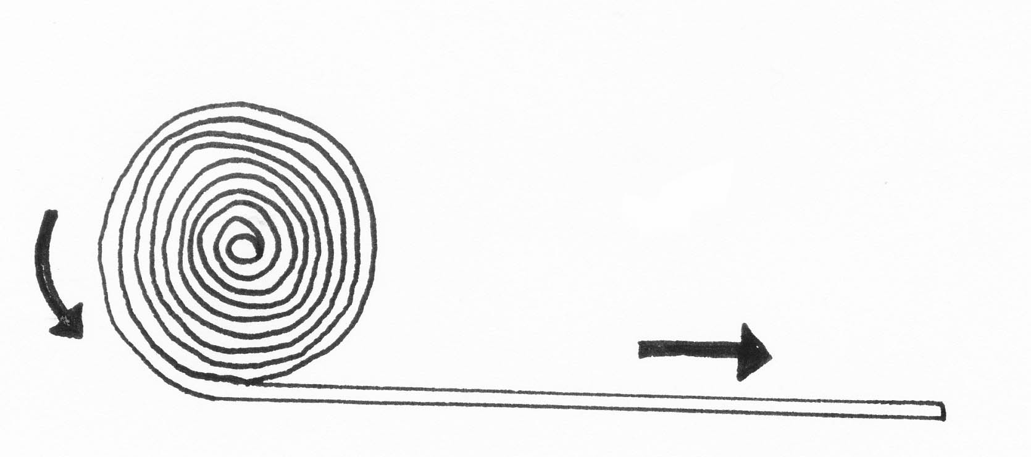
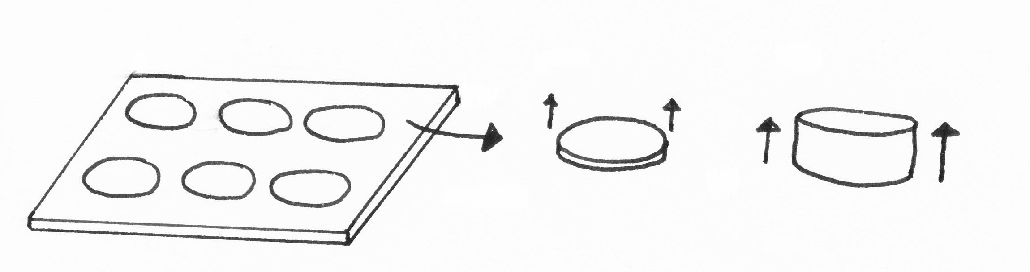
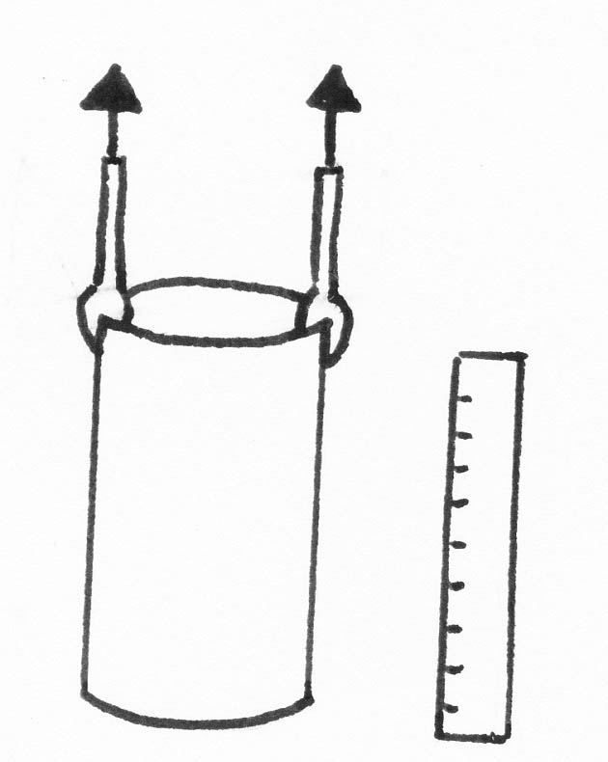
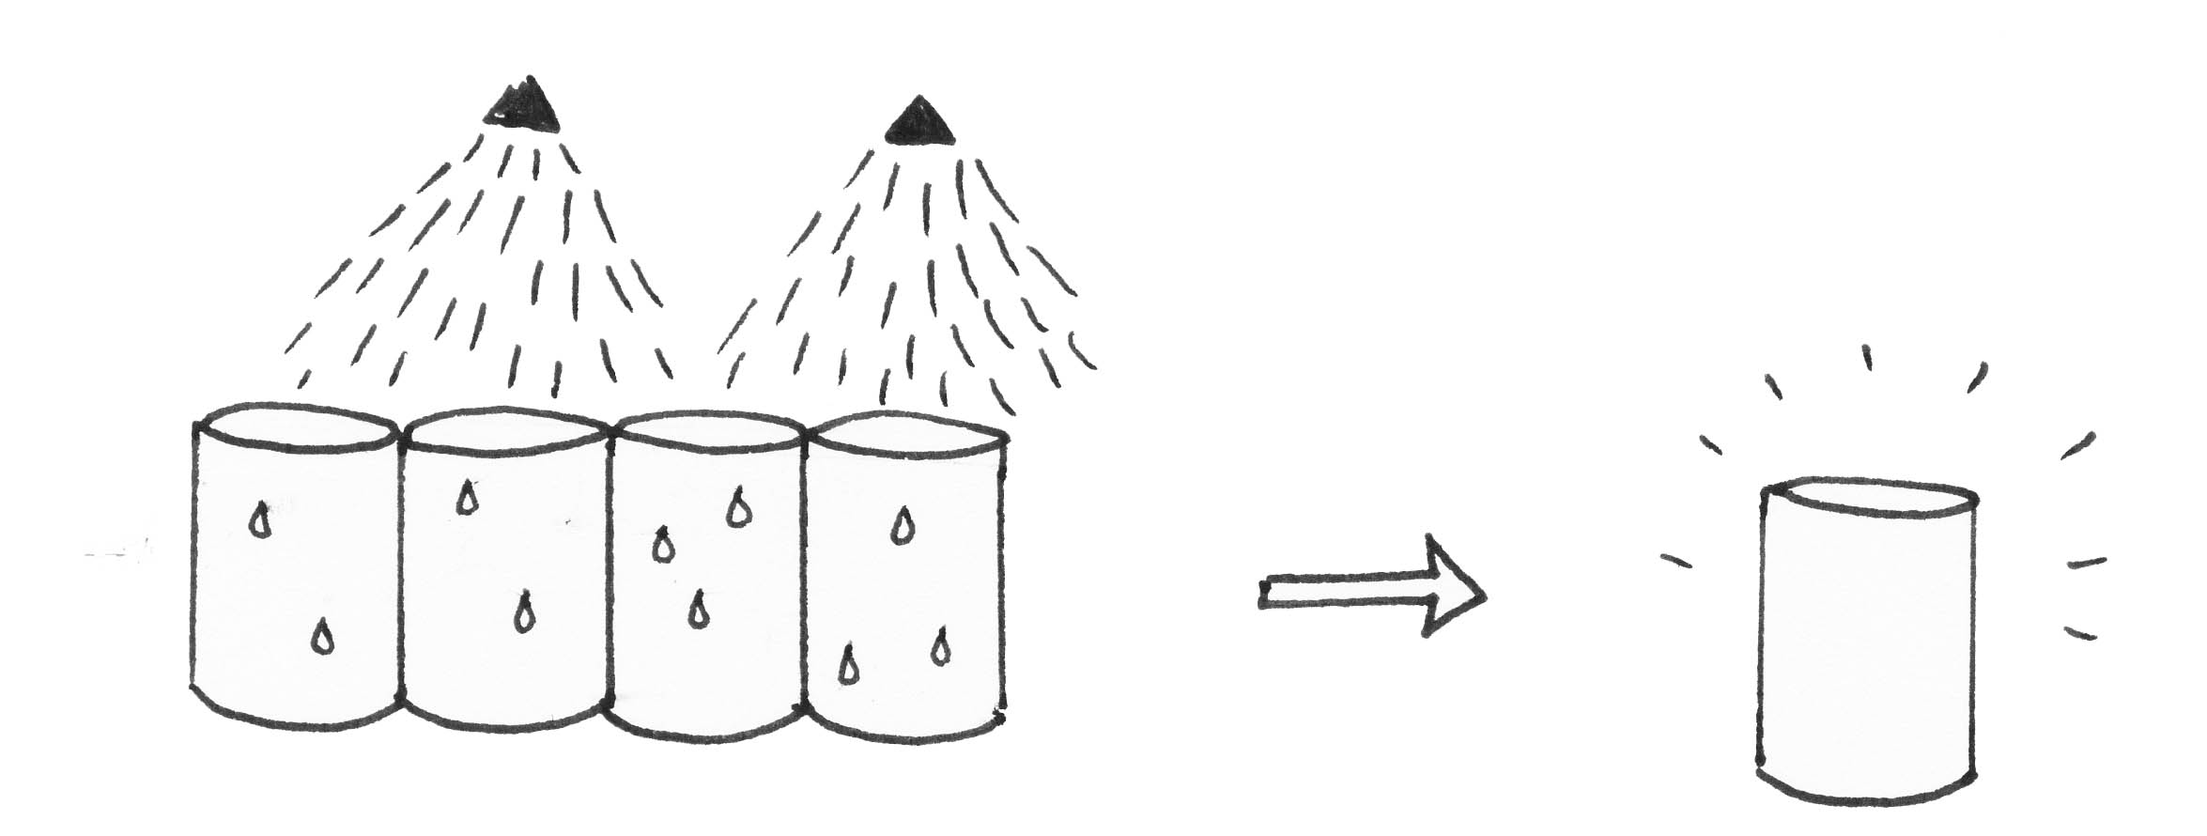
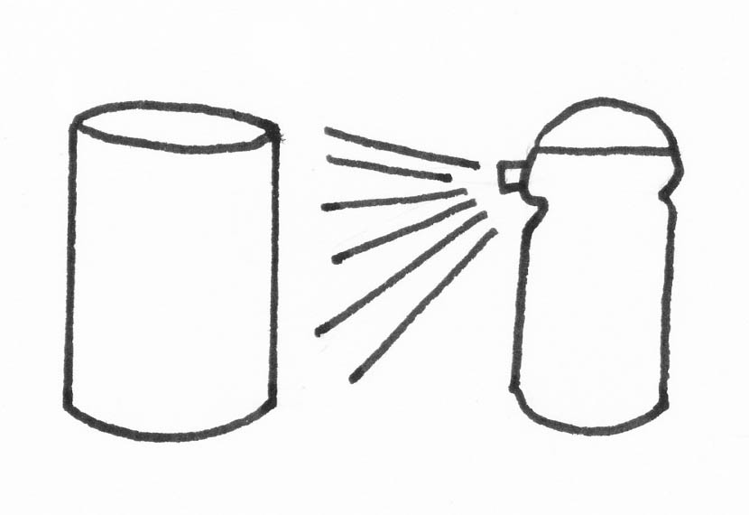
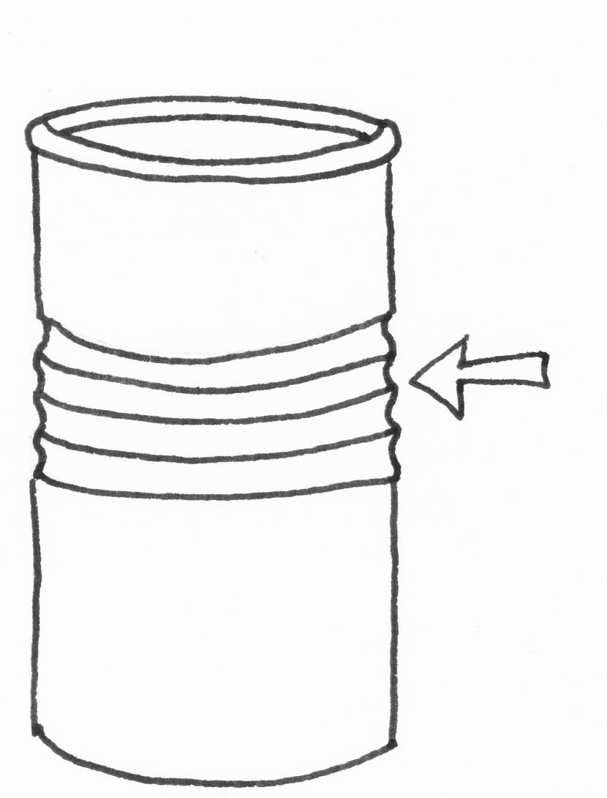
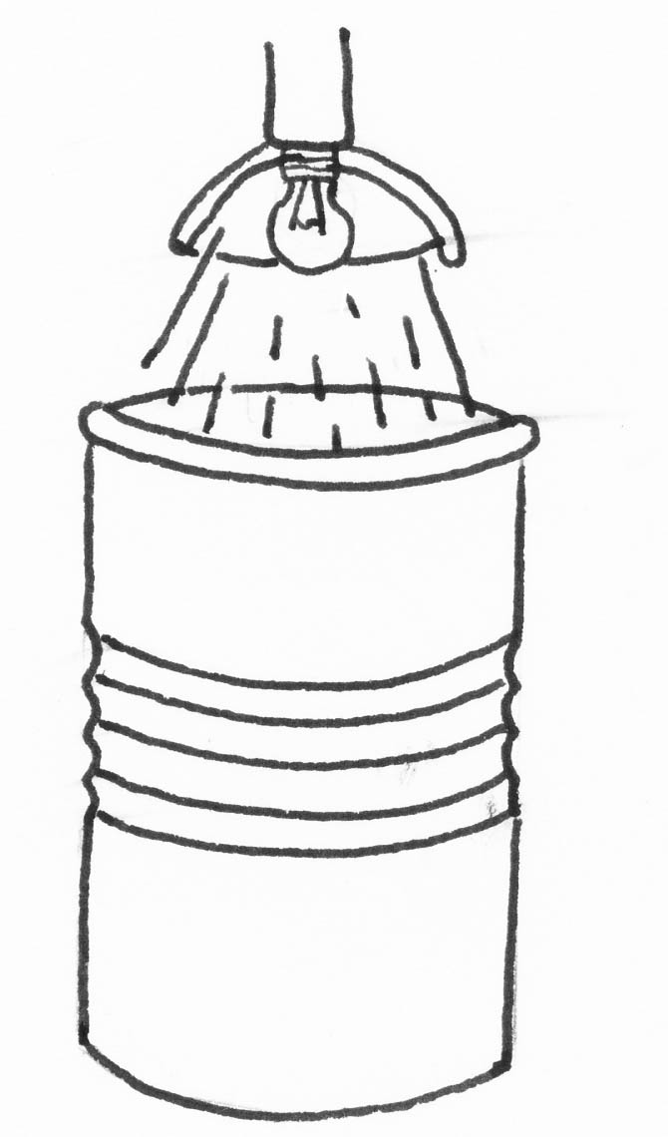
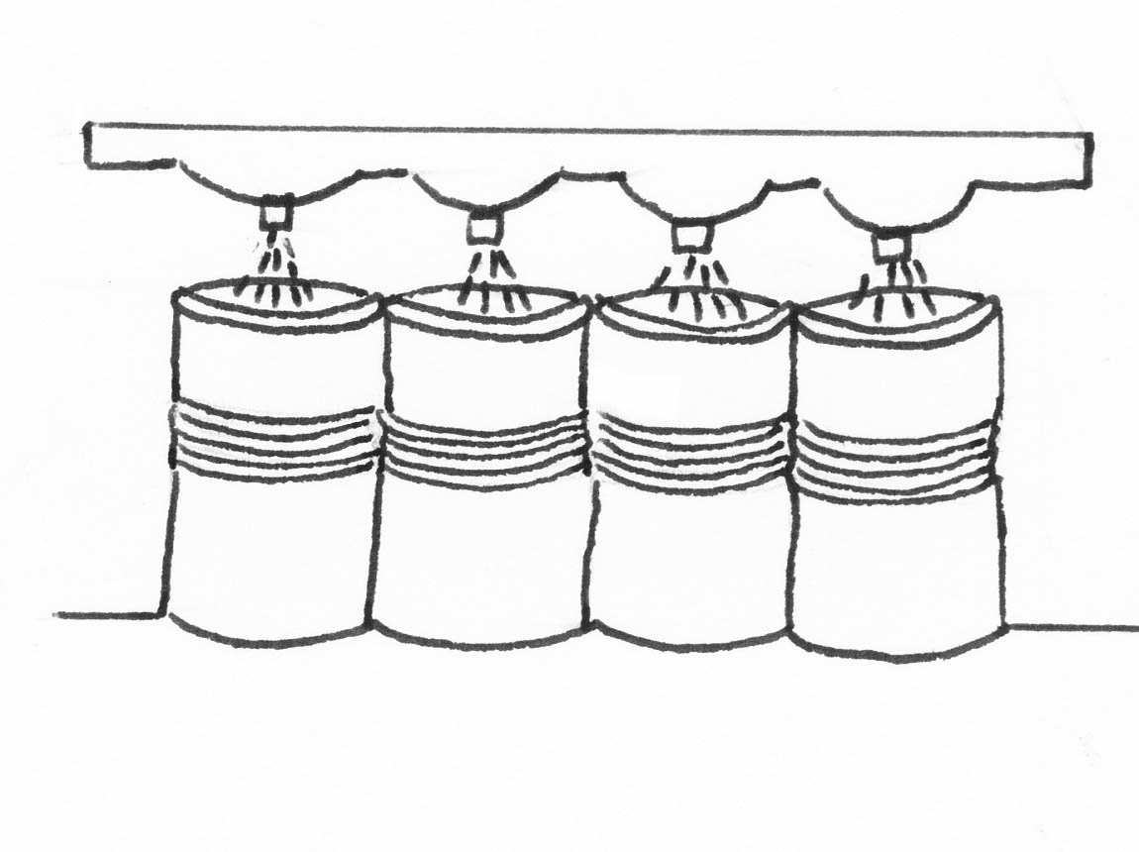
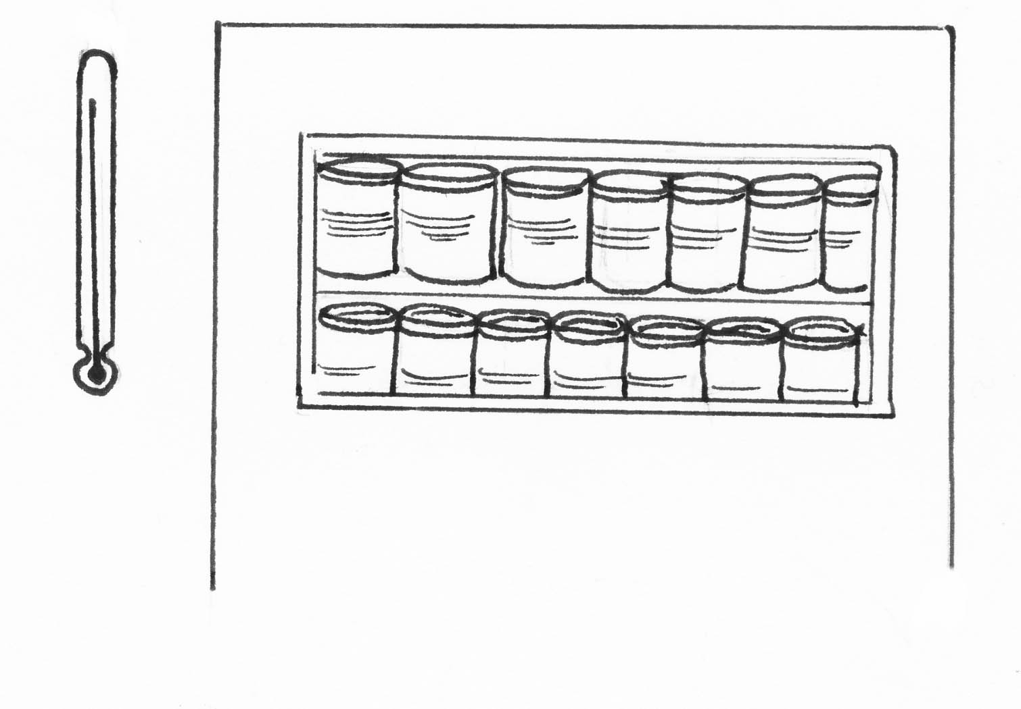
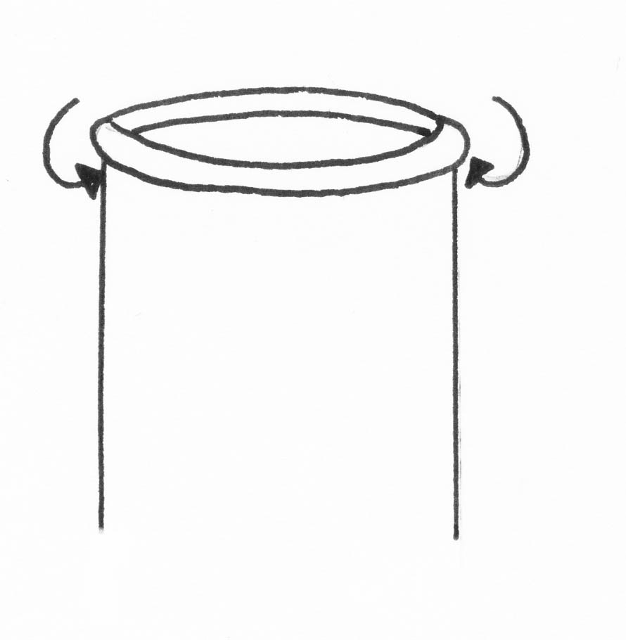
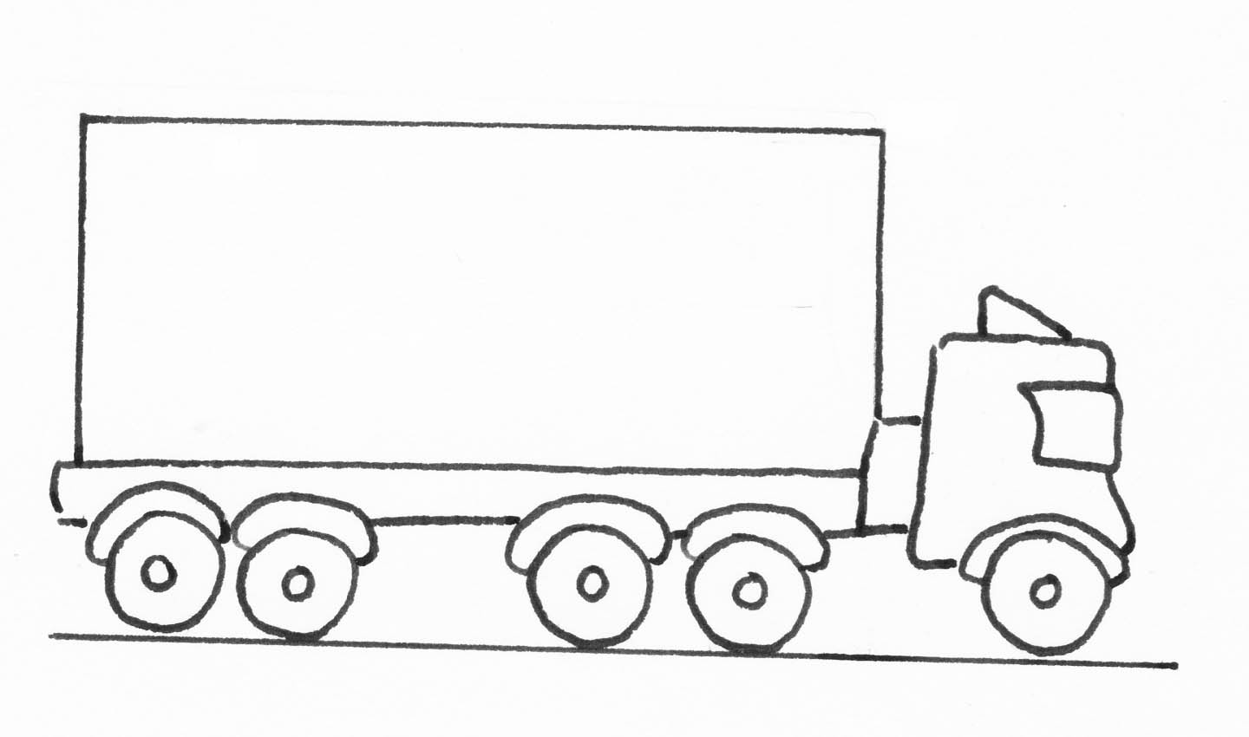
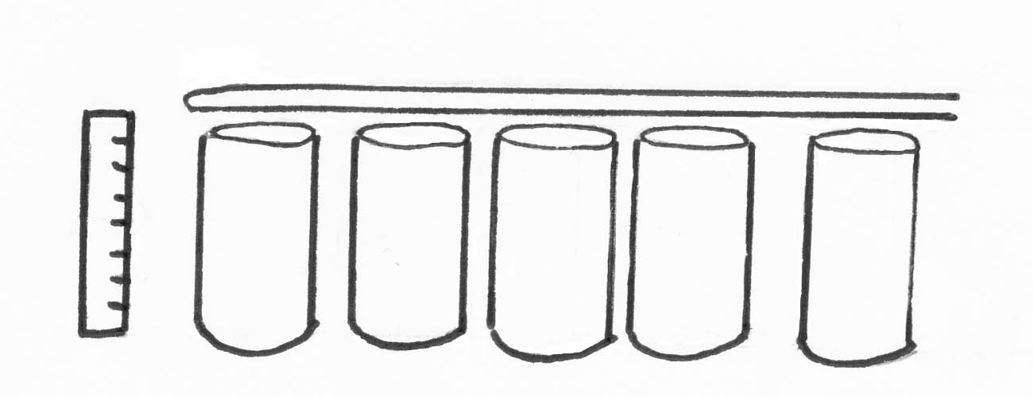

1
2
3
4
5
6
7
8
9
10
11
12
13
Making a
2-piece
Can
The metal used to make the cans arrives at the factory in big rolls.

The roll is fixed to a machine that unwinds it.

A circle shape is cut out of the metal and the sides are pulled up to make a cup shape.

The tops are trimmed so all the cans are the same height.

The trimmed cans are washed and dried.

A special coating is sprayed on the outside of the can to stop it rusting.

A ‘bodymaker’ machine pulls the sides up until they are the right height for the can.

Now the can goes into an oven to kill any germs.

Now the top of the can is curled over. The lid will fix onto here later.

Another machine makes the ridges on the side of the can. These make it stronger.

A bright light is shone into each can to check that they have no holes in them. Any with holes in are sent to be recycled.

A special coating is now sprayed inside the can to stop it rusting when the food is put in.

Finally, the cans can be packed up ready to go to the factory and be filled with food. The food factory will put the lid on.

Finally, the cans can be packed up ready to go to the factory and be filled with food. The food factory will put the lid on.

