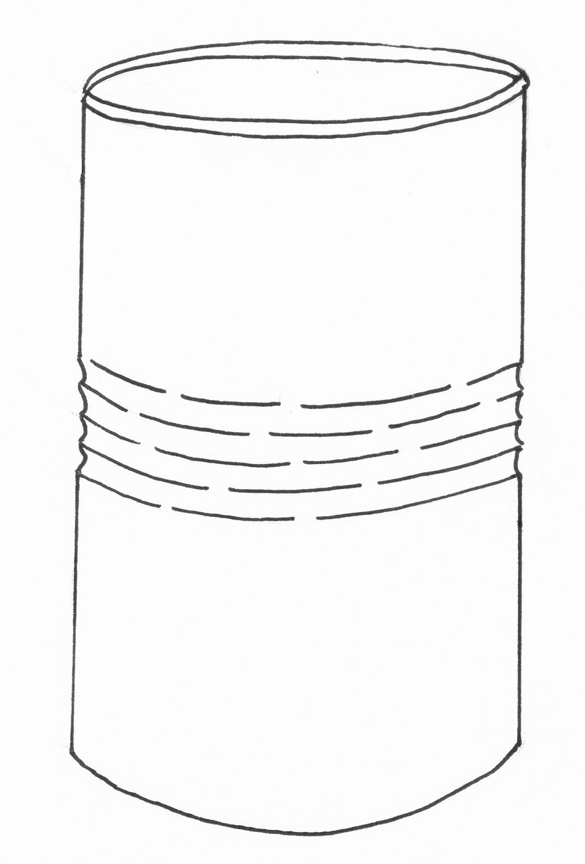
Hi Kids!
My name’s Stevie Steel and I’m a steel food can!
I bet you didn’t know all these facts about steel!!

Make this drinks can into a cartoon character called Stevie Steel!
Then use the ‘Did you know?’ sheet to fill in some facts about steel in Stevie’s speech bubbles

