

Age Group: Years 5 / 6
Curriculum Links: Creative use of ICT to support and enhance learning.

What do I need?
- Access to MS Word

The Unit, ‘Will it Fit?’ the pupils are asked to cut out a paper template of the can parts and arrange these on a template to work out the most efficient way of arranging them for minimal wastage.

This task shows pupils how this can also be completed using ICT using Microsoft Word.

Pupils can then compare the two methods and decide which is easier and more effective.

You will need: ‘Creating Shape Templates on MS Word’ Instruction Sheet

Using the information in the ‘Will it Fit’ unit, deliver the lesson as suggested, but instead of the class cutting out the templates, they each use a computer to create their calculation.

- Load up a blank MS Office page. This page is A4 size, yet the challenge is for an A3 page. If the page is presented as a landscape page, then pupils can imagine that this landscape page represents 2 A4 pages together (A3). Turn a page landscape by going to ‘File’, ‘Page set-up’, then choose ‘Landscape’

- If this page is now representing A3, discuss with the children what they are going to have to do with the given dimensions fo the cans. The page on their screen is half the actual size of the page. Thus, they will need to half the dimensions to estimate how many will fit on an A3 page.
- Choose one can to work with, i.e. the tomato soup can. On their page, the pupil will need to create a circle and a rectangle to represent the can parts. Allow the pupils to use the instruction sheet , ‘Creating Shape Templates on MS Word’ provided to learn how to do this.
- Complete the activity as on the original unit.
- Compare the two methods. Is it easier, more accurate to use the computer or the cut out method? Which method do the class prefer? Why?

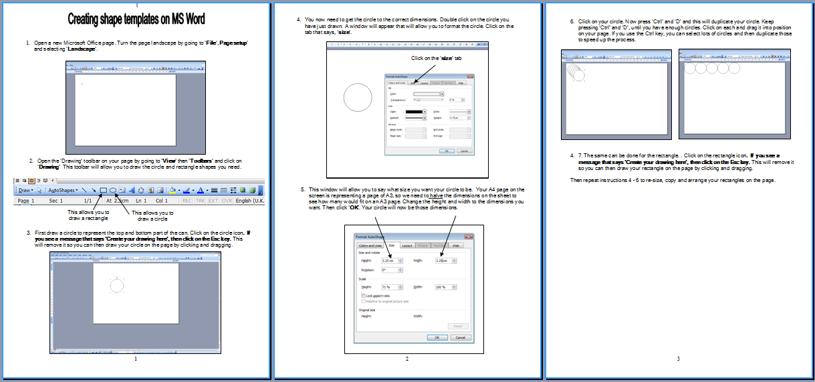

- Can the pupils create a spreadsheet to input the data and calculate the surface areas and wastage as on the ‘Packaging Engineer Data Sheet’.?

