- Open a new Microsoft Office page. Turn the page landscape by going to ‘File’, Page setup’ and selecting ‘Landscape’.

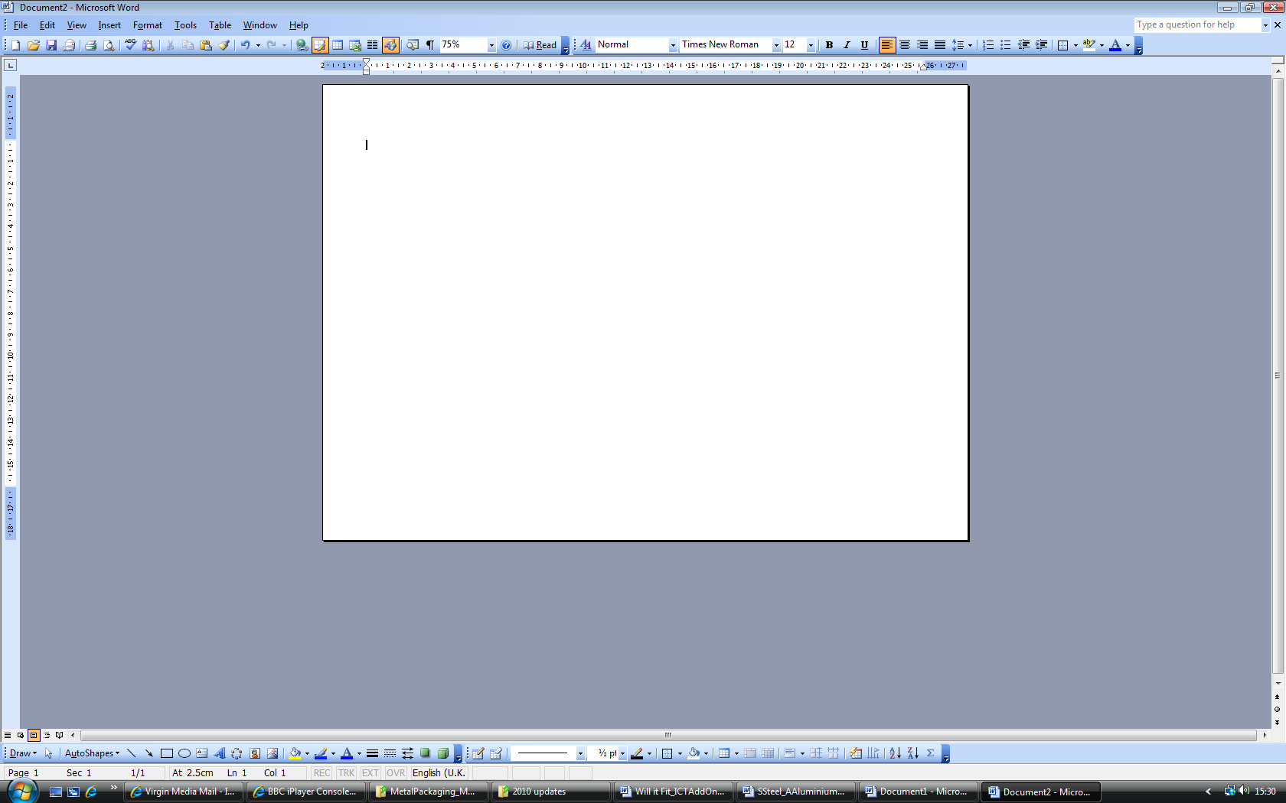

- Open the ‘Drawing’ toolbar on your page by going to ‘View’ then ‘Toolbars’ and click on ‘Drawing’ This toolbar will allow you to draw the circle and rectangle shapes you need.

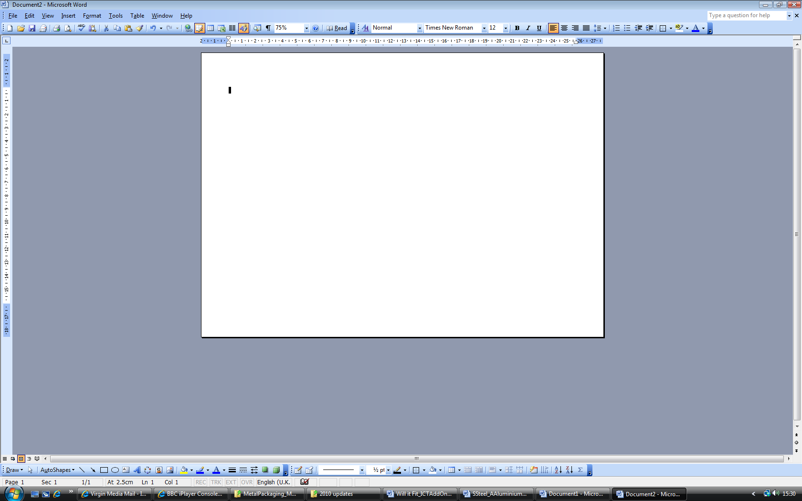
This allows you to draw a circle
This allows you to draw a rectangle

- First draw a circle to represent the top and bottom part of the can. Click on the circle icon. If you see a message that says ‘Create your drawing here’, then click on the Esc key. This will remove it so you can then draw your circle on the page by clicking and dragging.

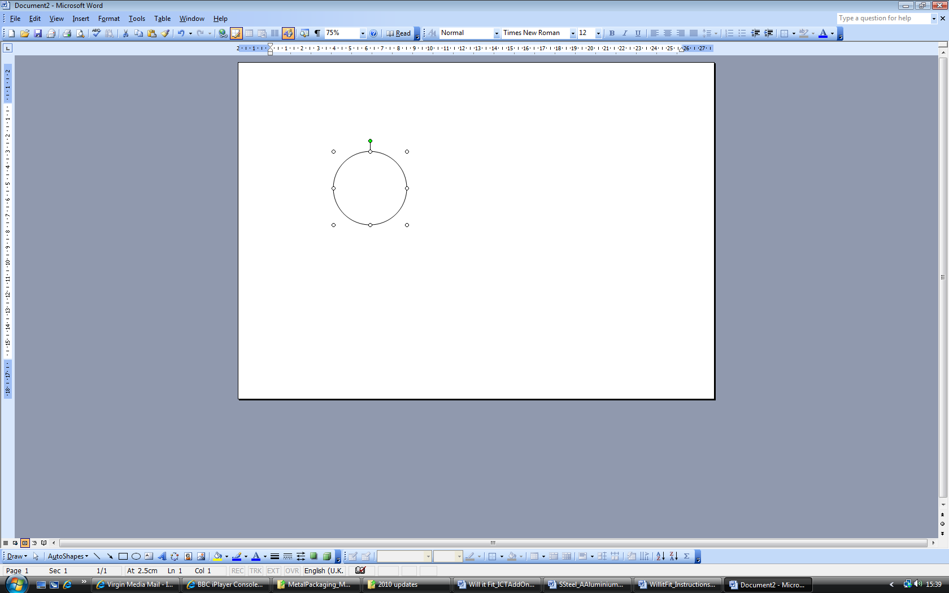

- You now need to get the circle to the correct dimensions. Double click on the circle you have just drawn. A window will appear that will allow you to format the circle. Click on the tab that says, ‘size’.

- This window will allow you to say what size you want your circle to be. Your A4 page on the screen is representing a page of A3, so we need to halve the dimensions on the sheet to see how many would fit on an A3 page. Change the height and width to the dimensions you want. Then click ‘OK’. Your circle will now be those dimensions.

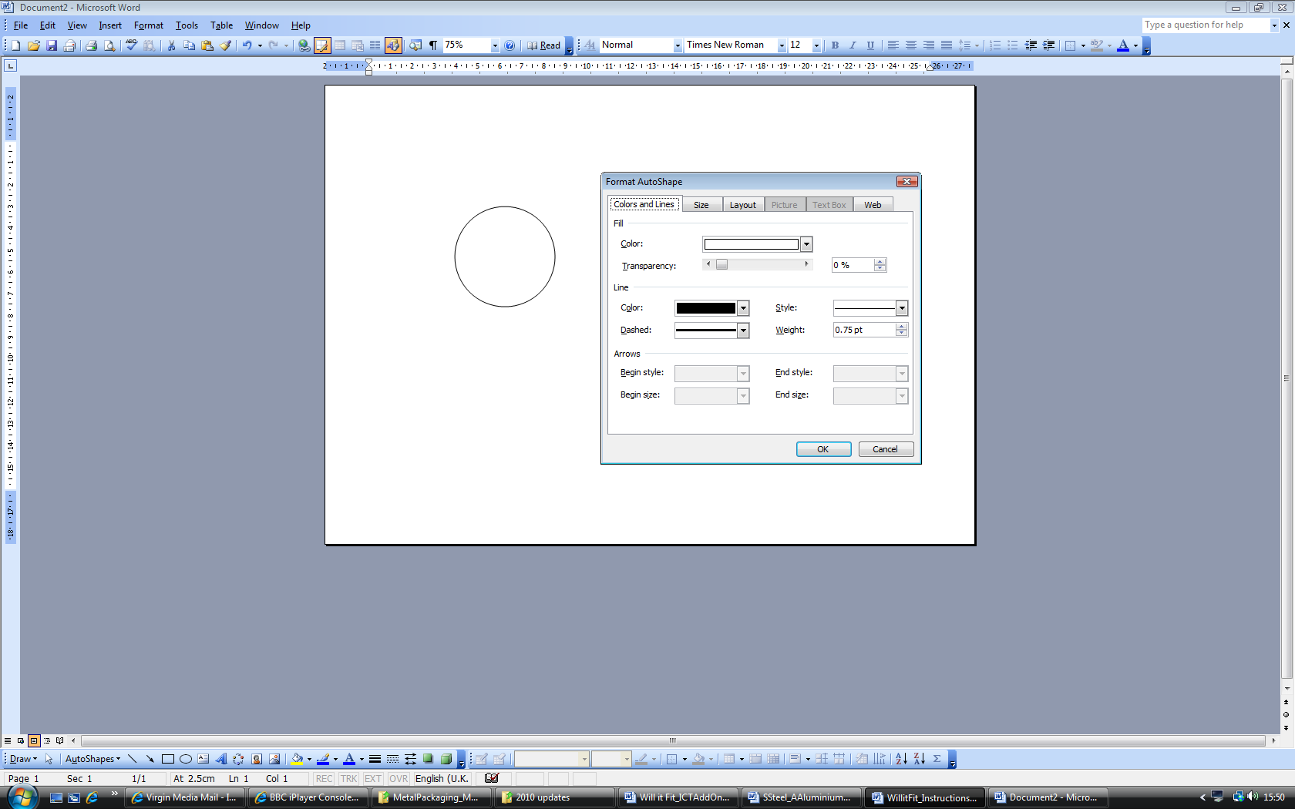
Click on the ‘size’ tab

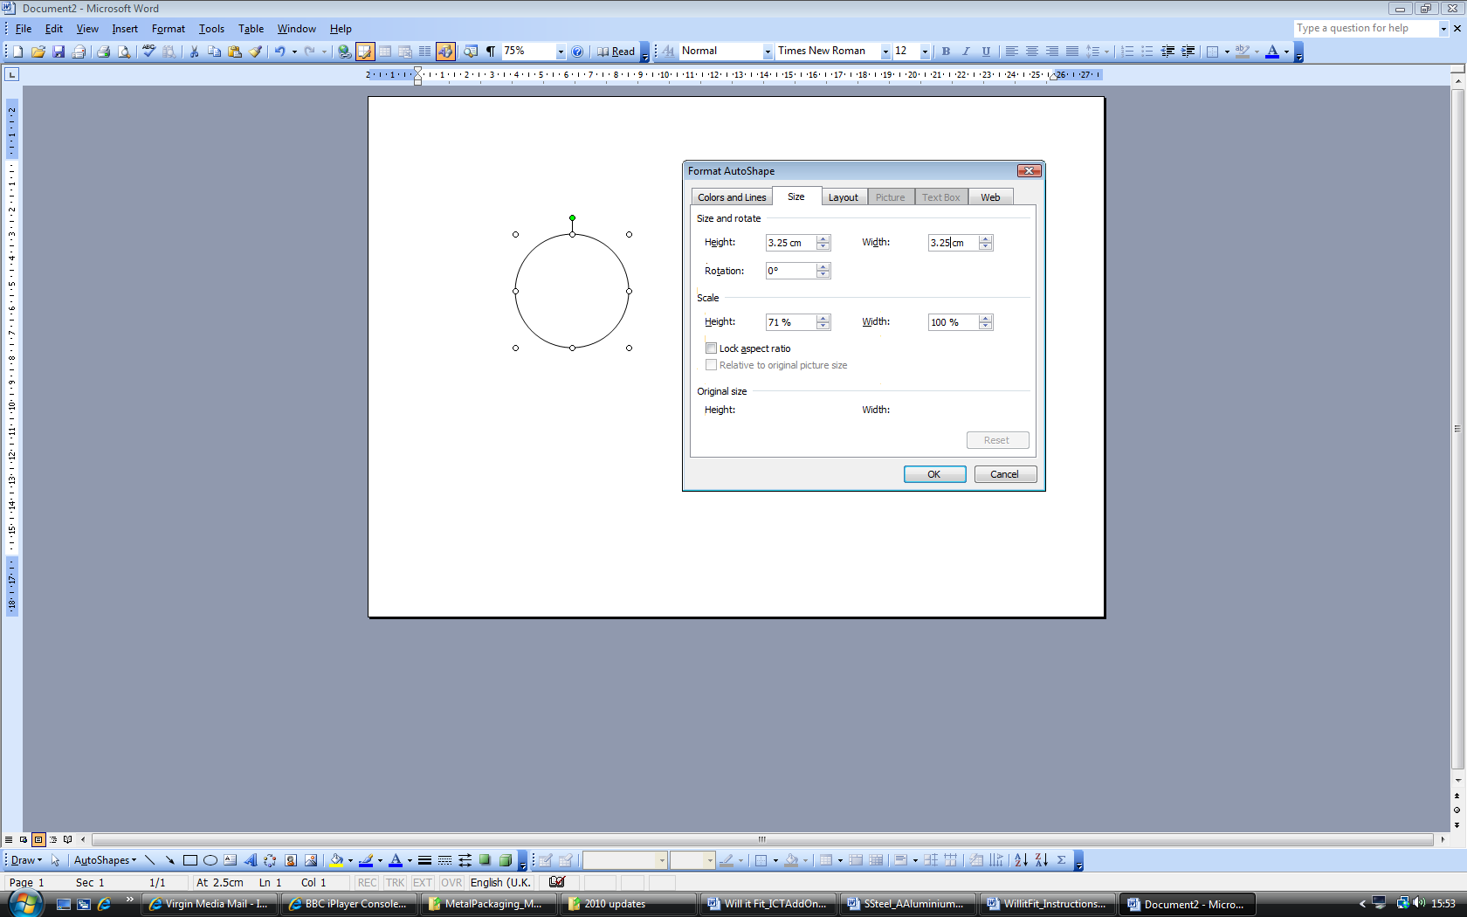

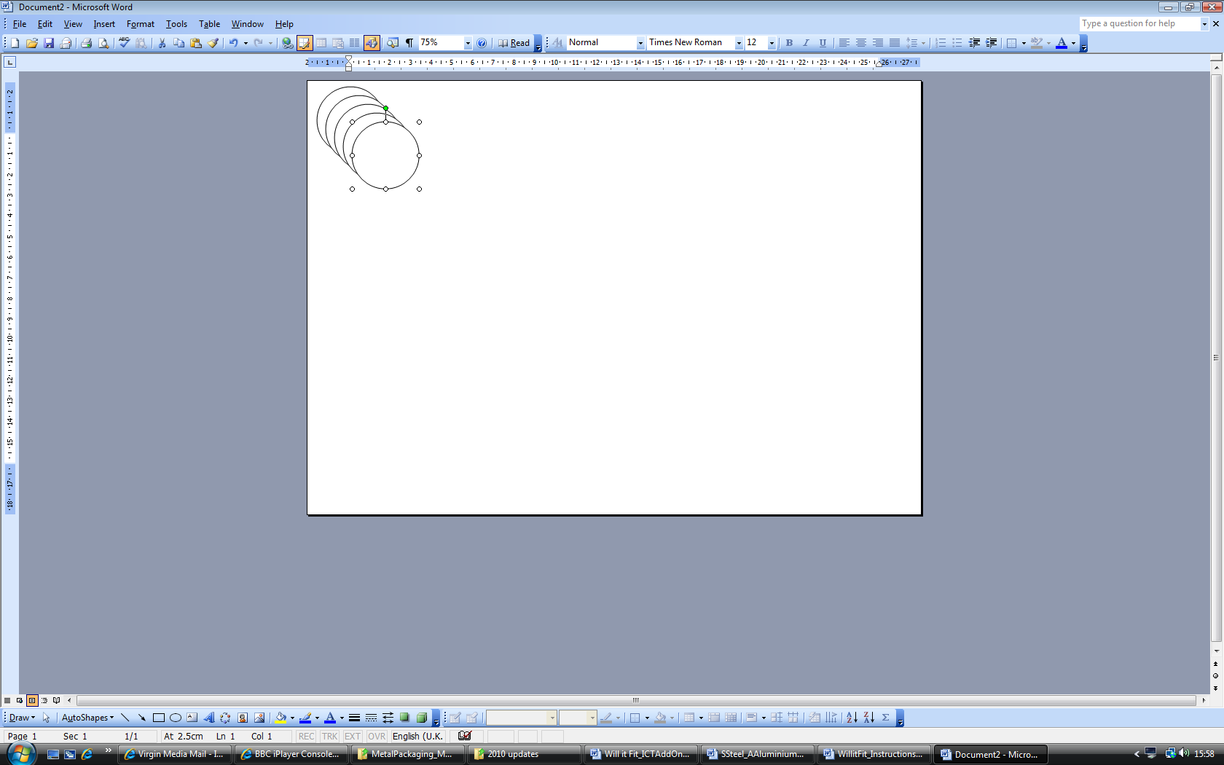
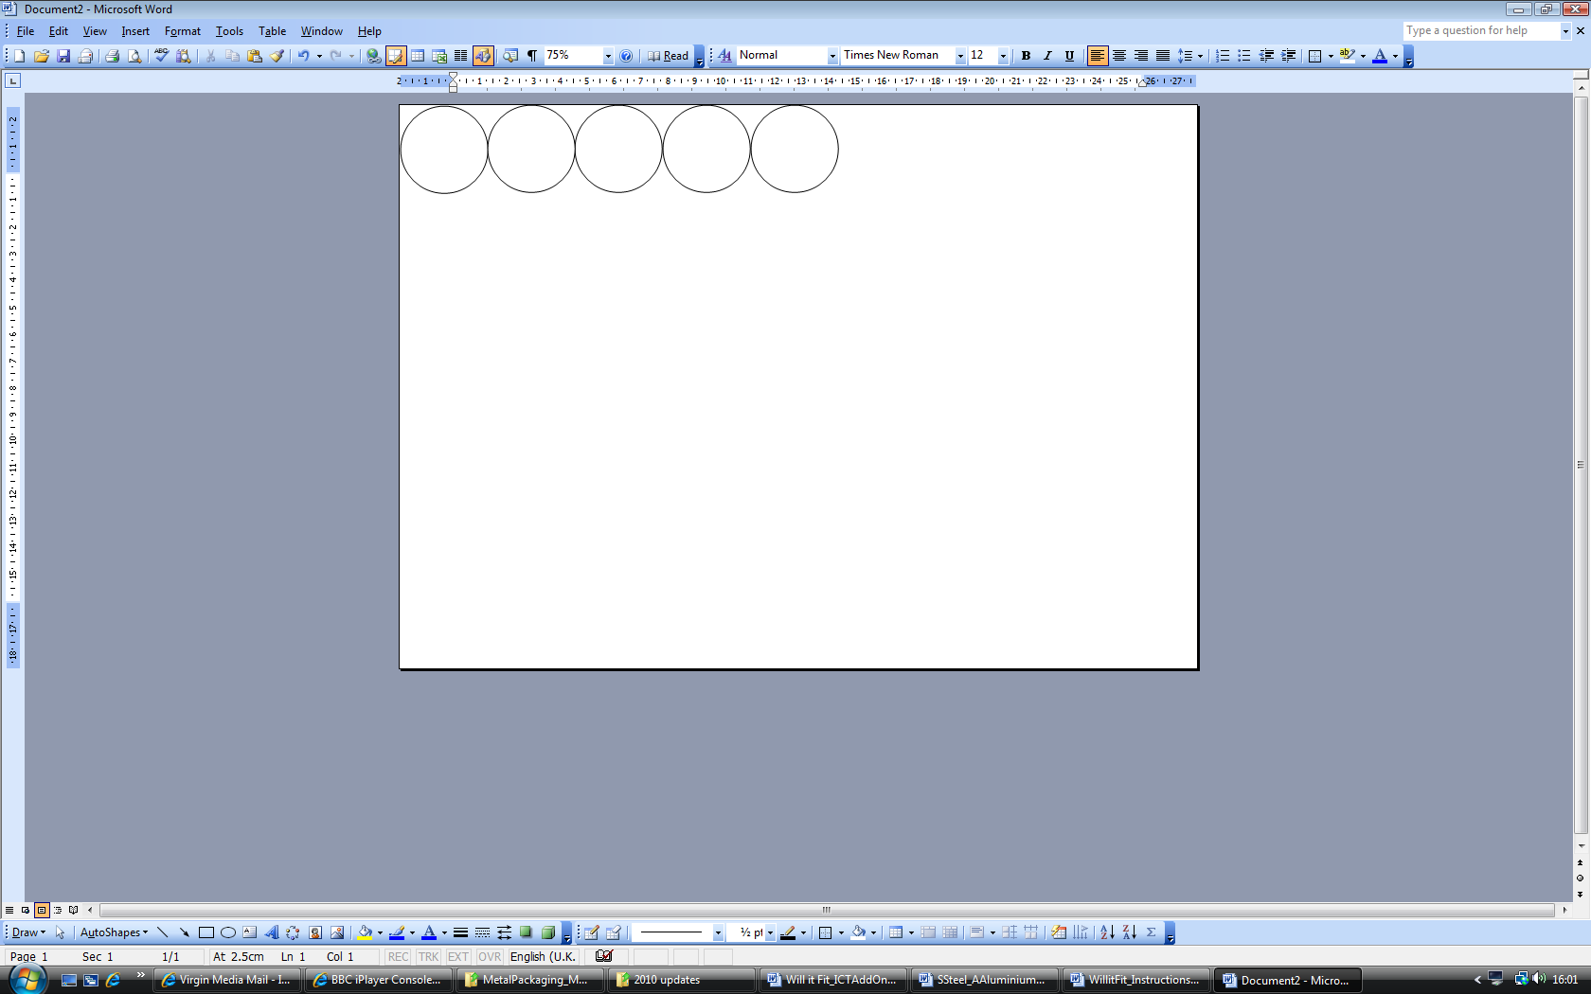
- Click on your circle. Now press ‘Ctrl’ and ‘D’ and this will duplicate your circle. Keep pressing ‘Ctrl’ and ‘D’, until you have enough circles. You can use the arrow keys to position your circles or click on each and drag it into position on your page. If you use the Ctrl key, you can select lots of circles and then duplicate those to speed up the process.

- 7. The same can be done for the rectangle. . Click on the rectangle icon. If you see a message that says ‘Create your drawing here’, then click on the Esc key. This will remove it so you can then draw your rectangle on the page by clicking and dragging.

Then repeat instructions 4 – 6 to re-size, copy and arrange your rectangles on the page.

