

Age Group: Years 5 / 6
Curriculum Links: Numeracy: Problem solving to include; addition, subtraction, surface area, tessellations.
What do I need?
- Selection of cans
- A3 paper, scissors
- Calculators

All of the tins and cans we see on our supermarket shelves begin life as flat sheets of aluminium or steel. These are then cut into the component shapes that will go to make the tin or can. It is important that as many parts as possible are fitted onto each flat sheet to minimise wastage. Any wastage that there is, is recycled.

This unit is numeracy based, giving the children the challenge of calculating ways to get as many component shapes as possible into a given area. They will be working as’ Packaging Engineers’ who have to design the layout for the cutting machines, work out the wastage left from each sheet and look for ways of minimising this through different arrangements of the components on the sheet.

Work Sheets 1, 2 and 3 - Dimensions of three types of can
Work Sheet 4 – Data Sheet for answers

Knowledge needed: Children will need to know how to work out the area of the bodies of the cans and the area of the A3 sheet. They will need to think logically and work through the problem. Due to some of the numbers used (real can sizes) a calculator will probably be needed.

Explain to the children how all the cans and tins they see are made from huge flat sheets of metal. These flat sheets are fed in to a machine which cuts out the shapes needed to make the can. Obviously, it is very important that there is as little waste as possible, so plans are drawn up as to how the shapes are to be arranged on the sheets. There will always be some bits left over, especially if circular shapes are being cut out. This wastage is recycled.

Explain to the children that they are going to be the ‘packaging engineer’ that is going to draw up the plan for a selection of cans to be cut from some sheet metal. The cans are ‘real’ size, but for this activity, the children are to imagine that the sheet size of metal is going to be A3. In fact, the sheets are enormous – too big a size for children to tackle in school!

Show the children Work sheets 1, 2 and 3 that show the dimensions of three different sized tins. On each sheet, the lid / base is shown, with its diameter and surface area. Also the

body part of the can is shown, with its length and width given.

Discuss with the children the values given and see if they can calculate the surface area of the can body for each of the three can types.

Explain that the machine that will cut these parts is going to work with metal sheets that are A3 size (2, A4 sheets). Their first task is to cut out the can parts and then arrange them on an A3 sheet and see how many they can get on. Preferably, have one sheet for bodies and one for tops. They have to try and waste as little as possible.

Once they have arranged the parts on the sheet, they need to work out the area of wastage. They should be able to work out the area of the A3 paper. Knowing the surface area of each can top and each can body, they should be able to work out the total surface area covered by these parts. By subtracting the surface area of the parts from the area of the A3 sheet, they can work out the waste.

Using worksheet 4, the children can fill in all the data they have taken and the answers to the calculations they have made.

Compare answers – who has managed to have the least amount of waste and how did they manage to achieve that? Discuss the tessellation of circles and how they can best be arranged to minimise waste.

The children could then try mixing bodies and lids on one A3 sheet – can they produce more now and have less wastage?

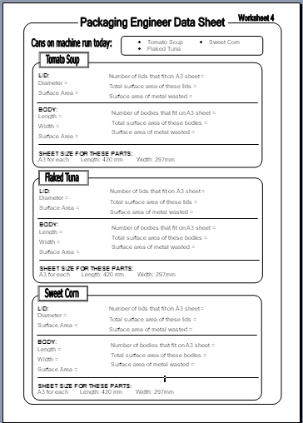

Try the same activity, but using different sized pieces of paper to represent the metal sheet. Also, measure some other cans and use their dimensions.

Think about other shapes of tin – what shape tin would ensure no waste from an A3 sheet?

